I need to discuss Dr Jenny Brown here to bring credibility to my business. How I found her program and how it transformed my parenting journey. Work with me button under “about Lil’ write up

Website Reworked
Changes to Home Page
Above the Fold
Name of business is no longer there at the top of the home page. What’s better:
- Write name as you previously had (thinking I prefer this option), or
- Enlarge Restore logo?
Midwife & Life Coach
***Change words to MIDWIFE, PARENT & LIFE COACH
Mid-page sections
***Addition: Following the first fold just go straight into:
Hi, I’m Lil, founder of Restore Coaching.
I created this work from my own journey of learning how to parent with more calm, clarity, and intention.
Now, as a certified coach with a background in midwifery, I guide parents to break reactive cycles and build confident, connected relationships with their children.
Because motherhood isn’t just about having a baby—it’s about who you become, how you show up, and how your family grows along the way.
[Read more →]
Next:
How I Can Help

Services Offered
Change Heading to : HOW I CAN SUPPORT YOU
Change Subheading to: Helping you restore how you show up in life, relationships, and parenting.
***Addition: Followed by: I offer in-person sessions across Lake Macquarie, Newcastle, and the Hunter, with in-home visits available for motherhood support.
Online and phone coaching is also available across Australia and New Zealand.
***Addition: With Icons row (to match delivery of services) directly underneath.
For example:📍 In-person 🏡 In-home support 💻 Online sessions📞 Phone coaching (love your icon choices so happy for you to pick relevant ones)
***Change order of service tiles and wording:
Service Tile 1:Parent Coaching
One-to-one support to help you move from reactive patterns into calm, confident parenting so you can respond with clarity and connection through every stage of your child’s development.
Read More
Service Tile 2: Birth Debrief & Early Motherhood Transition Support
Process your birth experience, release guilt and overwhelm, and feel supported as you move through early motherhood and identity change.
Read More
Service Tile 3: Emotional Intelligence Coaching
Build self-awareness, strengthen emotional regulation, and shift how you respond under pressure so you can relate more calmly and intentionally.
Read More
Service Tile 4: Life Coaching
Explore mindset, identity, and limiting beliefs so you can create meaningful change and live with greater clarity, confidence, and alignment.
Read More

Next, instead of this button below,

Change: Content under this button to be brought onto home page under service tiles (love it as is) but with wording changes below:

Remove
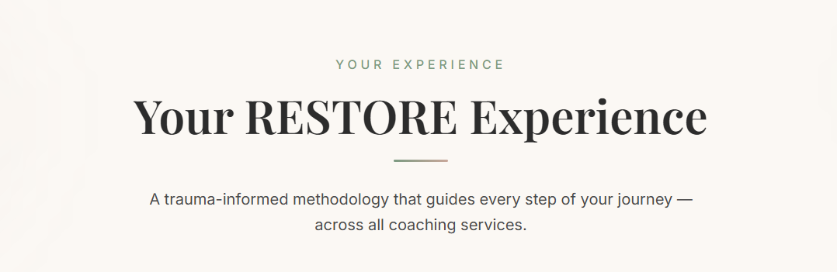

Content will start with The Methodology and include new wording below:
THE METHODOLOGY
The RESTORE Method
The RESTORE Method is a structured yet flexible coaching approach designed to build self-awareness, strengthen emotional intelligence, and shift how you show up in life, relationships, and parenting.
It helps you move out of reactive, autopilot patterns and into a more intentional, regulated, and aligned way of living.
While the method provides a clear pathway, the experience is tailored to you—your story, your season, and what you’re navigating right now. No two individuals or families are the same, which is why this work is never one-size-fits-all.
With a grounded and supportive approach, you are guided to create meaningful, sustainable shifts—building confidence, emotional capacity, and deeper connection in yourself and your relationships.

After this new content comes this R-E-S-T-O-R-E acronym - we currently have this wording:
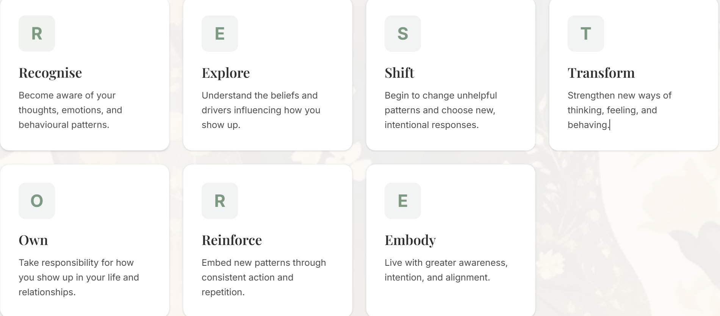

***Change wording to what’s below here (visually everything stays the same).
R — Recognise
Become aware of your thoughts, emotions, and behavioural patterns, and how they influence the way you show up.
E — Explore
Understand the beliefs, experiences, and internal drivers shaping your responses and patterns.
S — Shift
Begin to release unhelpful patterns and choose more intentional, regulated responses.
T — Transform
Strengthen new ways of thinking, feeling, and behaving that support lasting change.
O — Own
Take responsibility for how you show up in your life and relationships, with greater awareness and intention.
R — Reinforce
Embed new patterns through consistent practice, awareness, and repetition.
E — Embody
Live with greater emotional awareness, alignment, and confidence in how you show up each day.

THE TRANSFORMATION
The RESTORE Shift
The RESTORE Shift is the moment things begin to feel different.
It’s where self-doubt softens, reactive cycles start to break, and you begin responding with greater calm, clarity, and confidence, both internally and in your relationships.
Followed by before and after boxes (no change):
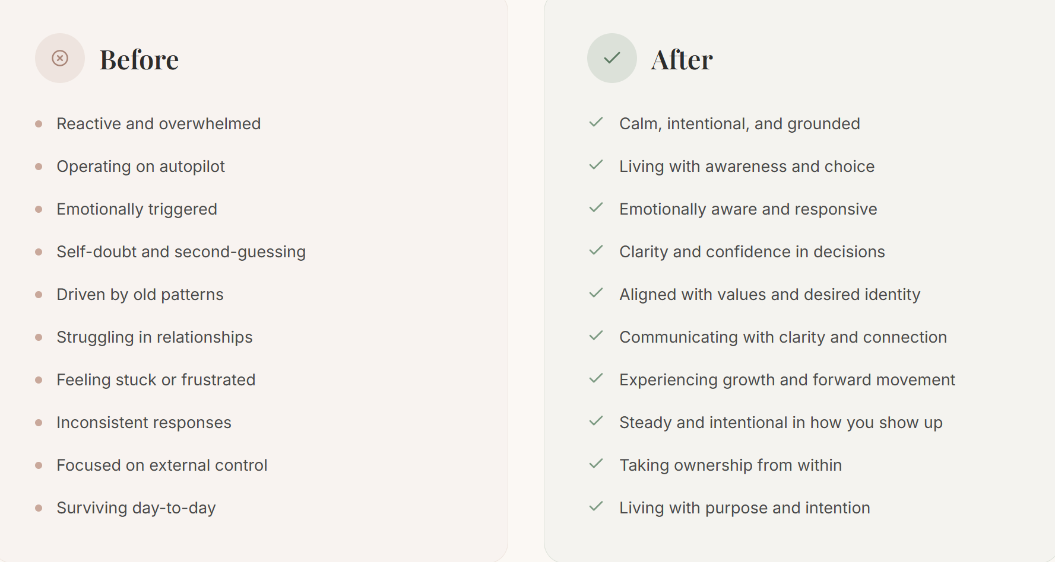
Following this we currently have two closing statements
- “From autopilot and overwhelm…”
- “Where you trust yourself…”
***Change to one sentence instead, with visual appeal (as you already have done)
From autopilot and overwhelm into intentional, grounded, and confident living, where you trust yourself, respond with clarity, and show up in life, relationships, and parenting with steadiness and purpose.
***Change: Move CTA (which currently sits at the bottom of the home page to go under the RESTORE Shift and change it from

Original
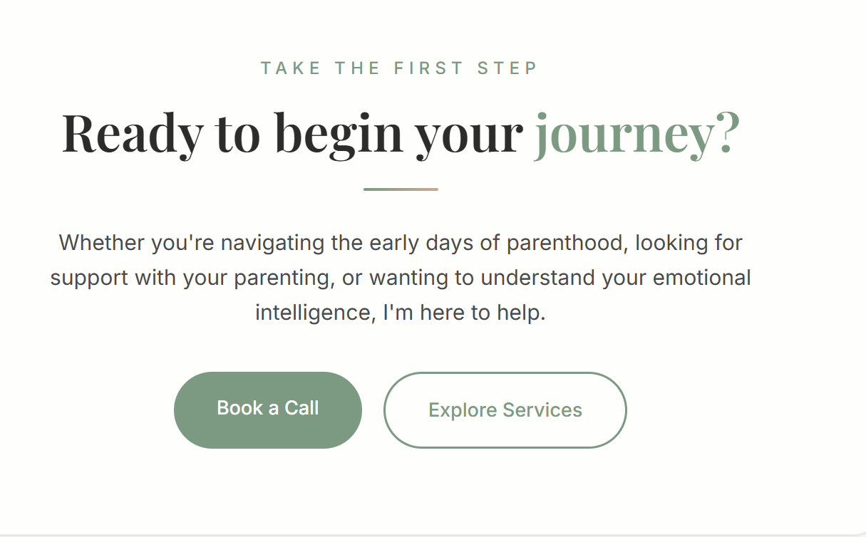
To:
Heading: Ready to begin your shift?
If this resonates with where you are right now, you don’t need to keep navigating it alone.
Together, we create space to understand what’s happening beneath the surface, break reactive patterns, and support you to show up with more calm, clarity, and confidence in your life, relationships, and parenting.
Change doesn’t happen all at once, it begins in moments of awareness, support, and a willingness to do things differently.
[Book a Session] [Enquire Here]
Let’s take the next step together.
Next- Testimonials section
***Change current wording to:
Heading: Real shifts. Real families. Real change.
Subheading: From reactive patterns to confident, connected parenting
These are the kinds of shifts people experience through RESTORE Coaching:
[ rotating testimonials ] – but please note currently testimonials are scrolling to fast.
Followed by Footer:
Currently have this: Supporting women and families through the emotional journey of parenthood. From birth story healing to confident, emotionally aware parenting.
***Change wording to below in relevant sections:
Restore Coaching with Lil
Helping you move from reactive patterns into calm, confident connection.
Quick links
- Home
- About
- Work With Me
- Packages
- Contact / Book
Contact
- Email
- Location: Newcastle / Lake Macquarie / Online Australia & NZ
Leave everything else as is (credentials, specialisations and accreditations)!

About Page
***ADD new paragraph to be included in content I already have:
About Lil
Midwife, Parent Coach & Motherhood Advocate
With over 26 years as a midwife, I've had the privilege of walking alongside women and families through some of life's most transformative moments. I've witnessed the beauty, vulnerability, and emotional complexity of becoming a parent—and how deeply those early experiences shape everything that follows.
But this work is not just professional, it's deeply personal.
My journey into coaching began as I navigated raising a neurodiverse child. Like so many parents, I searched for answers, strategies, and support that would create real change. Yet despite everything I tried, nothing brought the breakthrough I was longing for.
What I came to realise changed everything: the shift I was seeking didn't begin with my child; it began with me.
As I transformed how I saw myself, how I regulated my emotions, and how I showed up, everything around me began to shift. Not perfectly, but powerfully. That internal change reshaped both my parenting and my life, and I couldn't believe the impact it had on my family.
It was during this season that I was introduced to the work of Dr Jenny Brown, a psychologist with over 30 years’ experience supporting families.
Her program, Parent Hope Project, became the turning point in my parenting journey. It gave me a framework to understand behaviour, emotional regulation, and my role within the family dynamic in a way that finally created real and lasting change in our home.
As I began to trust in myself, I began to trust in my child, and this work gave me the framework to do that.
It was from this place that I felt a deep drive to bring this work to other families—because I had experienced firsthand the kind of change that is possible. I am formally trained in and deliver this program as part of my coaching practice, and today it forms the foundation of my Restore Confident Parenting program, where I guide parents through these same proven principles in a supported and practical way.
It was from this place that I felt a deep drive to create something more, not just for myself, but for other families.
The impact was so significant that I knew I wanted to bring this work to other families. I am formally trained in and deliver this program as part of my coaching practice, and today it forms the foundation of my Restore Confident Parenting program, where I guide parents through these same proven principles in a supported and practical way.
Alongside this, through my work in midwifery, early motherhood support, life coaching and emotional intelligence coaching, I began to see consistent patterns across the families and individuals I was supporting. From this, I developed the RESTORE Method, my own structured coaching approach that integrates these insights into a broader framework for personal and relational transformation.
Today, as a heart-led parent coach, I bring together decades of clinical experience, emotional intelligence training, and lived wisdom. I support parents to move beyond reactivity and self-doubt, and into self-trust, emotional awareness, and grounded confidence in who they are, regardless of the child they are raising.
My work goes beyond strategies. It's about transformation.
I guide parents inward, so they can lead their families with clarity, connection, and capacity.

🟣 EXPANDED SECTION for Parent Coaching ***change: Can we change the expanded Parent Coaching section layout so there is only 1 box, instead of two. I want a vertical flow.
Currently we have this: Keep headers, colours and font all the same 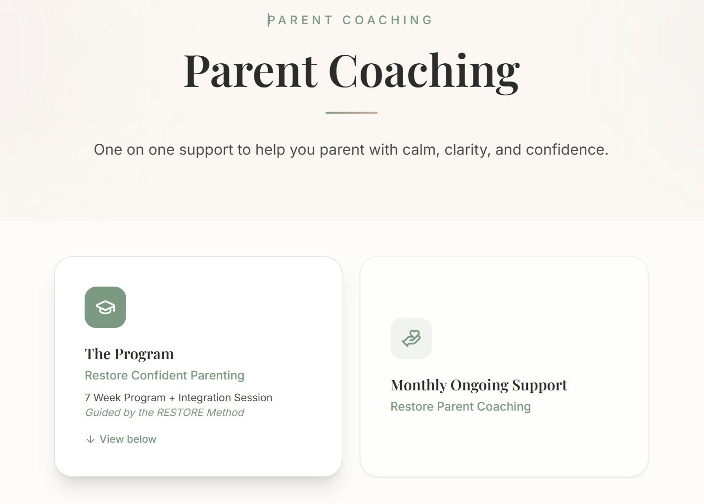
***but change framing sentence to: One-to-one support to help you move from reactive patterns into calm, confident, and connected parenting. Then change to:
🟦 BOX 1 (PRIMARY) all on its own-change wording to include all content below:
Heading - Restore Confident Parenting (remove title The Program please)
Subheading - 7-Week Transformational Program + Integration Session
Parent coaching with RESTORE begins here.
This structured program helps you understand the patterns driving your reactions—your triggers, emotional responses, and automatic behaviours—so you can begin responding with greater awareness and intention in everyday parenting moments.
As this awareness builds, real change begins to show up at home:
- more pause instead of reaction
- calmer communication
- emotionally safer interactions with your child
Over time, behaviour softens, connection deepens, and parenting feels more intentional and less overwhelming.
A guided manual supports you in moving from reactive parenting into calm, confident, emotionally regulated responses—giving you practical tools for real-life moments.
[View Program]
After clicking view program
Same header: Restore Confident Parenting (no subheading)
***Change content to:
Within the RESTORE Confident Parenting Journey, each step builds your awareness, strengthens emotional regulation, and supports lasting change in how you show up in parenting.
This program is guided by a structured manual developed by psychologist Dr Jenny Brown, who has over 30 years’ experience working with families since the 1980s.
Next: visual pathway as we have already, BUT:
***Change to this new diagram below: I’ve slightly changed the wording
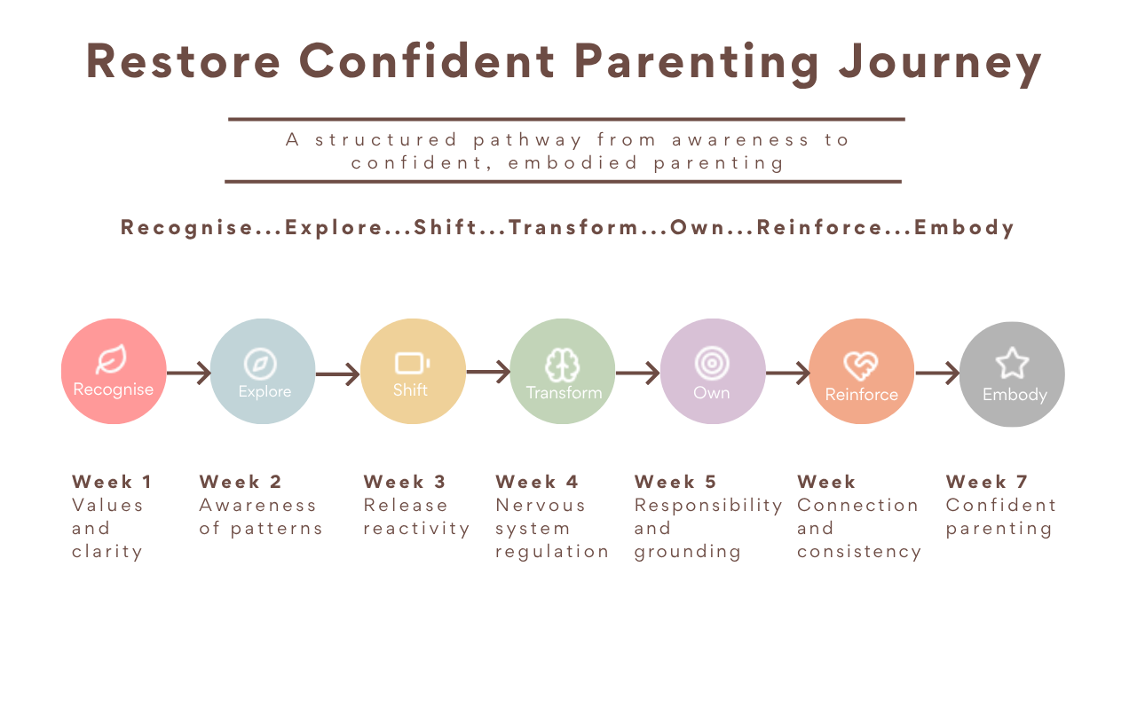
Next comes Restore Confident Parenting Journey week-by-week breakdown as we have, BUT:
***Change to different wording (see below) and with slight layout change of each box – no drop-down but just a box instead with explanation of each week with icons, colour fonts and everything else the same. Picture stays the same too!
Restore Confident Parenting Journey
This isn’t about learning more strategies. It’s about becoming the parent you already have the capacity to be.

Week 1 · Recognise
Reconnect with your values, your vision, and the parent you want to be.
You begin to feel grounded and clear in what matters most.

Week 2 · Explore
Build awareness of your patterns and responses.
Parenting shifts from autopilot into conscious awareness.

Week 3 · Shift
Release patterns that drain your energy and create disconnection.
Begin aligning with calm, connection, and resilience.

Week 4 · Transform
Strengthen your ability to regulate in real time.
Move from overwhelm into clarity and steadiness.

Week 5 · Own
Let go of guilt, pressure, and expectations that are not yours to carry.
Step into more confidence in how you show up.

Week 6 · Reinforce
Strengthen emotional connection through everyday interactions.
Build consistency, trust, and emotional safety.

Week 7 · Embody
Live the shift with greater confidence and consistency in daily parenting.

1 Month Later · Integrate
Ongoing support to embed change into real life and strengthen new patterns as challenges arise.

***ADD another BOX here:
Restore Confident Parenting
7-Week Transformational Program + Integration Session
Structured, guided coaching using the RESTORE framework
Psychologist-informed, manual-based process
Focus on emotional regulation, awareness, and parenting responses
Integration session to support real-life application
$2, 090 AUD
[Book Program]

Next comes Monthly Ongoing Support (as a secondary section).
Instead of a box I want this represented as a “support section” making Ongoing Support a full-width section under the program, not a clickable tile or equal card.
****Change Heading to: Ongoing Parent Coaching
***Change Subheading to: Continued support as you integrate and live the RESTORE work (with the same icon  & same colour)
***Change paragraph to: After completing the Restore Confident Parenting program, many parents choose to continue with ongoing support as they apply the work in real-life parenting situations.
Parenting doesn’t follow a perfect timeline, and neither should support.
This flexible coaching option is available at any stage of your parenting journey. Whether you're navigating a specific challenge or wanting deeper, long-term growth, you'll have access to guidance, perspective, and practical support when you need it.
We continue working together for as long as you need, supporting both immediate challenges and long-term transformation.
Follow this what is currently there:
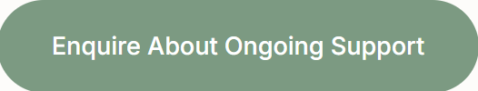

🟣 EXPANDED SECTION-for Birth Debrief & Early Motherhood Transition Support
Birth Debrief and *** add Early Motherhood Transition Support
Holding space for women to process their birth story and feel safe in motherhood.
***please add under above sentence - Trauma informed, non-clinical support

Remove all content and replace with 3 BOXES.
First 2 BOXES SIDE BY SIDE (box 1 birth debrief and box two birth debrief package), and keep image in this content where possible
BOX 1:Birth Debrief (your font and font colour as you have done)
Make sense of your experience
Every birth story carries meaning, emotion, and impact.
This is a safe space to process your experience and gently bring understanding to what unfolded.
Together, we make sense of your story so you can move forward with clarity, self-compassion, and emotional release.
Core transformation:
My birth story is part of me — but it does not define me as a mother. I feel grounded, clear, and more at peace with what has been.
BOX 2 Birth Debrief Package
$300 AUD
A supportive space to process your birth experience, gain clarity, and move forward with confidence.
What’s included:
- 60–90 minute 1:1 birth debrief session
- Personalised coaching summary
- Follow-up phone call
[Book a Birth Debrief]

Underneath Birth Debrief package comes:
Box 3: Early Motherhood Transition Support – vertical flow with all below content
Feel supported in what’s unfolding
Motherhood is not always what you expected — which is why it can feel destabilising.
You may be navigating feeding, settling, sleep deprivation, emotional waves, and identity change all at once.
This is support for the now.
Together, we regulate overwhelm in real time, build confidence in your responses, and help you begin trusting yourself as you grow into this new season.
You can choose the level of support that feels right for you.
***ADD: a Package outline following
Heading: Early Motherhood Transition Support Packages
Recommended for babies aged 0–18 months
Building Foundations
4, 8, or 12-week support options
Support designed to meet you where you are, helping you build confidence, clarity, and emotional stability over time.
Gently guided by the principles of the RESTORE Method, this work supports you toward calm, confident, and connected motherhood.
4 Weeks · Reset & Reconnect
“I don’t feel like myself… and I don’t know where to start.”
This is your starting point.
If you’re feeling overwhelmed or disconnected, this support helps you reset practically, mentally, and emotionally — guiding you back toward a calm, grounded foundation.
Focus:
- Reconnect with yourself after birth
- Create space and slow things down
- Establish feeding, sleep, and care rhythms
- Understand your triggers and anxiety
You’ll begin to feel:
- Less overwhelmed
- More grounded and supported
- Increasingly confident
- More self-aware and regulated

8 Weeks · Strengthen & Stabilise
“I want to stop second-guessing everything and feel more steady in myself.”
This is where things begin to shift.
You’ve started to reconnect — now we strengthen your inner stability so you can move through motherhood with more confidence and trust.
Focus:
- Build emotional steadiness
- Reduce self-doubt and overthinking
- Strengthen self-trust and decision-making
You’ll begin to:
- Feel more anchored in your choices
- Respond instead of react
- Show up with greater consistency

12 Weeks · Integrate & Embody
“I want to feel calm, confident, and capable in motherhood, not just get through it.”
This is the full integration.
You’re no longer just coping — you’re embodying a calmer, more confident version of yourself.
Focus:
- Integrate what you’ve learned
- Build internal calm and confidence
- Step into intentional motherhood
You’ll leave with:
- A strong sense of self
- Practical tools for long-term support
- The ability to navigate challenges with clarity and calm

***Then ADD this:
Building Foundations Packages
Choose the level of support that feels right for your current season:
- 4 Weeks — $1,250 AUD
- 8 Weeks — $1, 948 AUD
- 12 Weeks — $2, 565 AUD
Sessions are available online or in-person, depending on what feels most supportive for you. In-person sessions are available across Lake Macquarie, Newcastle, and the Hunter region.
[Enquire / Book Now]

🟣 EXPANDED SECTION-for Emotional Intelligence Coaching
After clicking on read more:
Keep what we already have for headings and frame, same colour, same font:
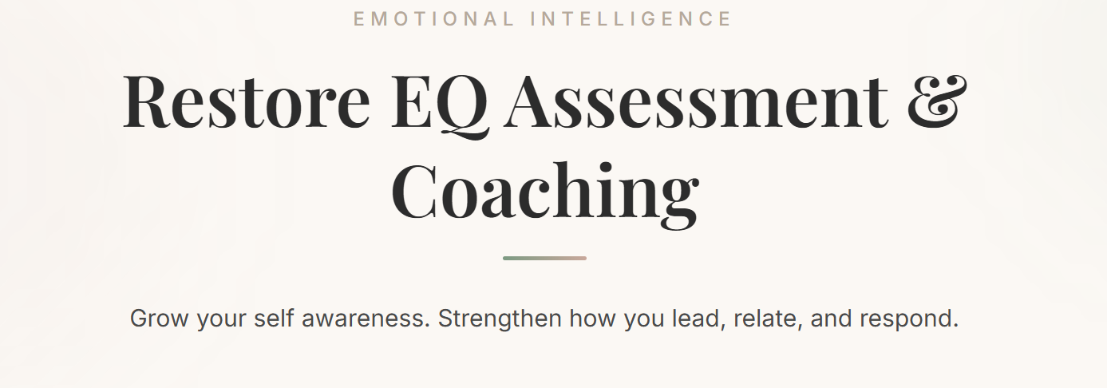
***Change description following, to this refined version below
Emotional Intelligence (EI) is the ability to understand and work with your thoughts, emotions, and responses in everyday life.
It influences how you handle stress, make decisions, build relationships, and navigate pressure at home, work, and in relationships.
Through the Emotional Quotient Inventory (EQ-i), you receive a personalised “map” of your emotional and social functioning — highlighting your strengths and areas for growth.
Next:
Same box layout as below, same icons and look, but with ***rewording changes,
Original:
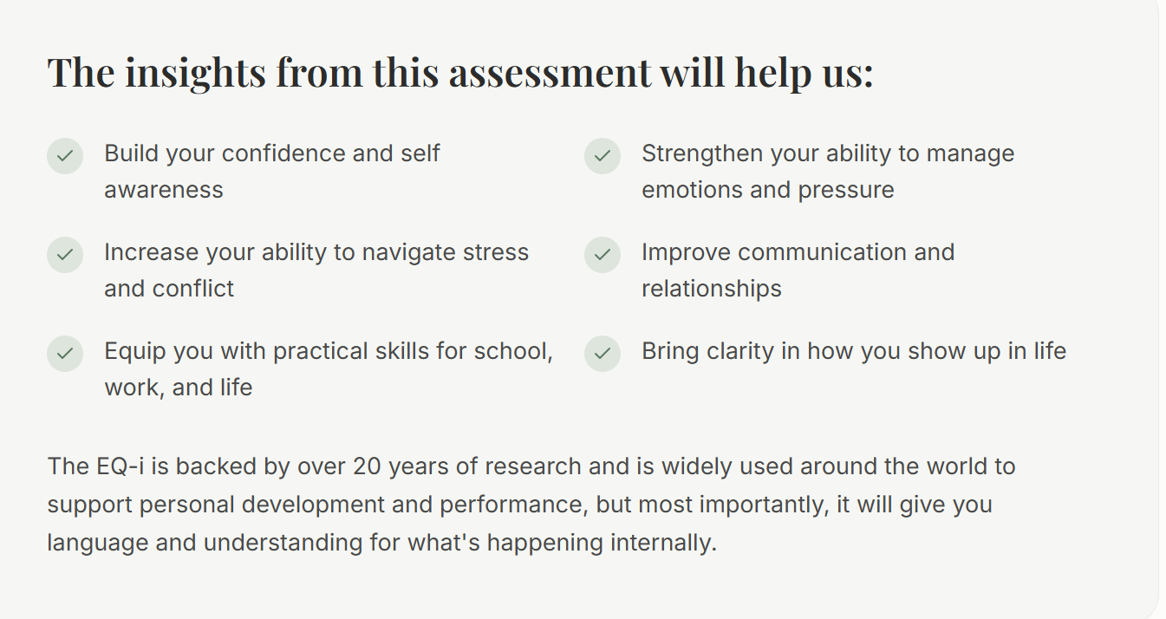
***Refined rewording version
The insights from this assessment support you to:
- Build self-awareness and confidence
- Strengthen emotional regulation under pressure
- Navigate stress and conflict more effectively
- Improve communication and relationships
- Develop practical skills for life, work, and parenting
- Gain clarity on how you show up in daily life
The EQ-i is backed by over 20 years of research and is used internationally in personal development and organisational settings.
Most importantly, it gives you clear language and insight into your internal world, so change becomes understandable, not overwhelming.
Next:
Same layout as below, with same icons (ticks), font and colour but with ***rewording changes
Original
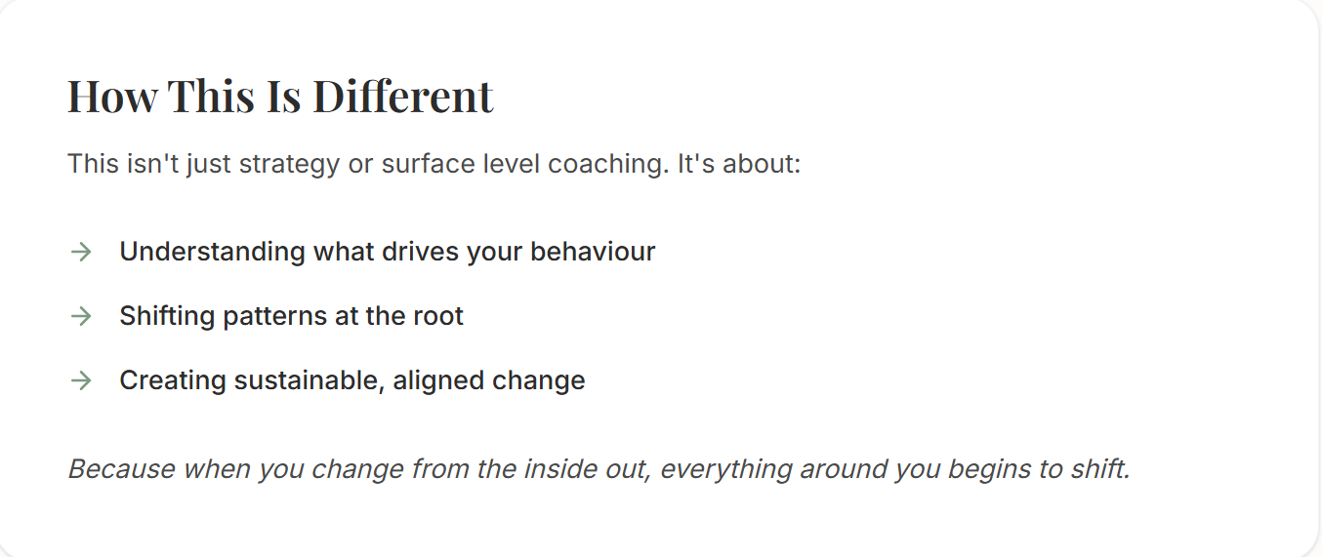
***Refined rewording version:
How this is different
This is not surface-level coaching or behavioural strategies.
It focuses on:
- understanding the patterns behind your reactions
- working at the root of emotional responses
- creating sustainable internal change
When you shift how you relate to yourself, everything else begins to shift with you.
***ADD a package outline:
Emotional Intelligence Coaching
$950 AUD
Strengthen your emotional intelligence so you can lead, relate, and respond with greater clarity and confidence in everyday life.
This is a structured coaching process combining assessment, insight, and applied integration work.
What’s included:
- Comprehensive EQ-i assessment and personalised report
- 90-minute results debrief session
- Two 60-minute coaching sessions (focused + integration)
- Three personalised coaching email summaries
Next:
Again, same layout, fonts, colour just ***changed wording:
Original:
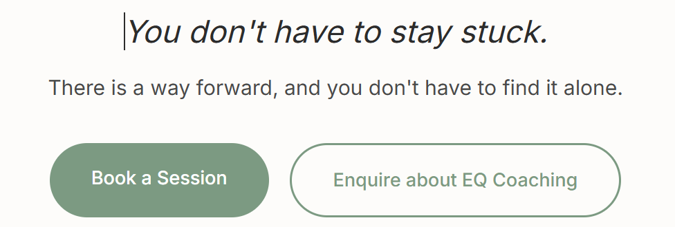
***Refined version:
Ready to explore your Emotional Intelligence?
If this resonates, you don’t have to navigate it alone.
There is a way forward, and we can work through it together.
[Book a Session]
[Enquire about EQ Coaching]

🟣 EXPANDED SECTION-for Life Coaching
After clicking on read more:
***Changes to wording, but headings and colours (as below) and layout all stay the same

***Slight reword change under headings to:
Whether you're seeking ongoing support or a single breakthrough moment, life coaching helps you move forward with clarity, direction, and purpose.
BOX 1 (Same icon, different title): Change to: Ongoing Life Coaching
***Changed wording: Regular, structured support for mindset shifts, identity work, and breaking through limiting beliefs.
We work together over time to support your growth, helping you step into the version of yourself you’re becoming.
BOX 2 (Same icon, same title): One-Off Coaching Session
*** Changed wording: A focused, single session designed to bring clarity and perspective when you need it most.
Ideal for decision-making, specific challenges, or moments where you feel stuck and need direction.
***ADD here package offer:
Ongoing Life Coaching
from $550 AUD/month
Tailored support based on your level of need and frequency of sessions.
Includes ongoing access, structured sessions, and support to help you integrate change over time.
One-Off Session
$300 AUD

This stays the same:
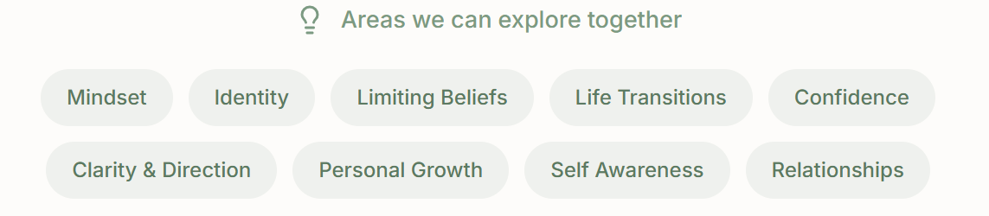
***Refined CTA:
Ready to start?
If you're unsure which option is right for you, a short clarity call can help guide your next step.
Book a 30-minute Clarity Call

COACHING PACKAGES PAGE — REFINED STRUCTURE
***Word changes-want to remove the word ‘investment’ but keep the layout, fonts, colour, tick icons all the same etc.
Coaching Packages
Explore each option with clear inclusions and support levels, so you can choose what feels right for your current season.

🟣 1. Birth Debrief
$300 AUD
A supportive space to process your birth experience, gain clarity, and move forward with emotional grounding as you enter motherhood.
Includes:
- 60–90 minute 1:1 debrief session
- Personalised coaching summary
- Follow-up phone call
[Book Session] [Get Started]

🟢 2. Early Motherhood Coaching Packages
Choose the level of support that meets you where you are in your early motherhood journey.
3 Package boxes still as you already have them but with different titles and slight layout changes:
BOX 1:
4 Weeks · Reset & Reconnect
In-person: $1250 AUD | Online: $1050 AUD
A foundational reset to help you feel more grounded, supported, and clear in early motherhood.
BOX 2:
8 Weeks · Strengthen & Stabilise
In-person: $1948 AUD | Online: $1568 AUD
Build emotional steadiness, reduce overwhelm, and strengthen confidence in your parenting responses.
BOX 3:
12 Weeks · Integrate & Embody
In-person: $2565 AUD | Online: $2025 AUD
Deepen your internal calm, trust yourself more fully, and integrate lasting change into daily motherhood life.
***Change: instead of repetition after all 3 boxes – ONE SHARED SECTION
Happy for it to be tick icons like you’ve done?
What’s included across all packages:
- Restore Journal (guided reflection companion)
- 1:1 coaching sessions (in-home or online)
- Personalised support tailored to you and your child’s needs
- Birth Debrief session (included in all packages)
- Flexible payment options available
- Additional sessions available at a reduced rate
With a CTA under this as you already have

🟣 3. Restore Confident Parenting Program (MAKE THIS YOUR PRIMARY SECTION)
Restore Confident Parenting Program
7-Week Transformational Coaching Program + Integration Session
$2,090 AUD
Flexible payment options available
A guided transformation helping you move from overwhelm into grounded, confident parenting.
Keep tick icons
- Restore Journal & pen (guided reflection companion)
- Restore Confident Parenting Manual
- 7 weekly coaching sessions
- 1 integration session (one month later)
- Personalised coaching email summaries
🌿 Start Your Journey
📞 Book Your Clarity Call

4.🟢 Restore Ongoing Support (keep tick icons)
from $550 AUD/month
For parents and individuals who want continued support and integration as life unfolds.
Ongoing coaching tailored to your needs, offering consistent guidance as you navigate parenting and personal growth.
May include:
- 1 x 60–75 minute monthly 1:1 session
- Weekly structured check-in
- Email/messaging support (48-hour response time)
- Emotional regulation + real-life integration support
- Priority booking for additional sessions
- [Enquire About Ongoing Support]
5. ⚪ One-Off Coaching Session
$300 AUD
A focused session for clarity, support, or breakthrough in a specific area.
- 60–90 minute 1:1 coaching session
- Personalised coaching summary
- Follow-up support
[Book Session]

***ADD new page titled: ‘Book a Session’ page
Header: Book a Session
Take the next step toward calm, confident, and connected parenting.
Clarity Call (30 minutes)
A short, one-to-one call to understand where you’re at and explore the best next step for you.
- Gain initial clarity and perspective
- Ask questions about the program
- Explore what support feels right
[Book a Clarity Call]

Ready to begin straight away?
If you already feel clear and ready to start, you’re welcome to book a full session.
[Book a Session]
[Enquire Here]
What to expect
If you’re here, something has already resonated.
You don’t need to have it all figured out — just a willingness to begin.
- We begin with a one-to-one conversation to understand your current challenges and goals
- Together, we explore what’s happening beneath the surface in your parenting
- You’ll gain clarity, practical tools, and a clear sense of your next steps
- From there, we can decide what level of support feels right for you
When you’re ready, you can take the next step here.
[Book a Clarity Call]

Rework this below it about lil page

Ongoing support for parents who want continued guidance, integration, and support as they apply the RESTORE work in everyday life.
[ About Lil page: Her work deeply shaped my transformation and practice, and I’ve developed my own structured coaching method (RESTORE) that reflects those outcomes.” ]
The RESTORE Method is a structured coaching framework shaped by my lived experience of Dr Jenny Brown’s parenting program and my work supporting parents through real-life change.
Dr Jenny Brown, a psychologist with over 30 years’ experience working with families since the 1980s, developed the foundational parenting program that first shaped my own parenting journey.
Then:
My RESTORE Method translates these principles into a structured coaching experience for modern parents.

